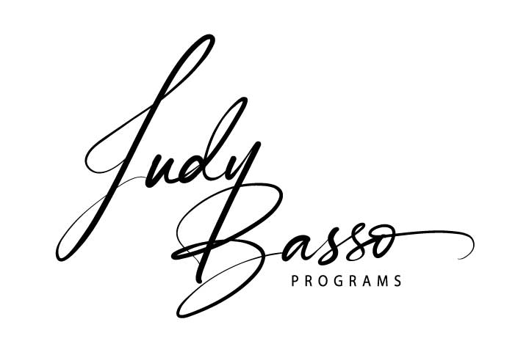
Business Vision Board Workshop –
With a Divine Twist
Questionnaire

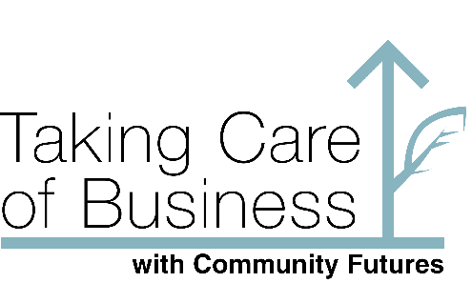

Why should I do a vision board?
It sounds good but… Focus on why you SHOULD do this program than why you shouldn’t.
Get clear on WHY this program will benefit you. Take a few minutes to answer the questions below truthfully.
- What areas of my business would I like to see differently?
- Now pick one of those areas and think of something specific that you like to see happen or have.
- What is the desired outcome? How would you feel if that would come to pass?
- What about my personal life? Answer 2 and 3 again with this in mind.
- Do I want to want change bad enough to dedicate the time and energy required for a day for me to be focussed exclusively on what my goals and aspirations are?
By taking action to make progress towards these goals will help you. Doing a Vision Board on the desires above will create an energy that magnetizes those items that you want to you. It is physics – the law of attraction at work. What have you got to lose?
See you there!

